Lab Assignment: Ecological Relationships

### Read and complete each step of the lab below.

1. Purpose:

The purpose of this lab is to determine the type of ecological relationships between two organisms found in nature.

1. Materials:

10 Ecological Relationship Cards (on your screen).

1. Procedure & Data Collection:
   1. At each station read the description provided on the Relationship Cards.
   2. In Table 1 write down the name of both organisms, which one benefits, which one is neutral and which one is harmed. Do not leave a column blank- for example, if neither organism is harmed you could write “none” or “neither”. I did the first on as an example
   3. Determine if the relationship is mutualism, commensalism or parasitism, predation or competition and record in Table 1*.*
   4. In Table 2*,* write a COMPLETE SENTENCE describing how the relationship was a symbiotic relationship of mutualism, commensalism, parasitism or non-symbiotic predation or competition. The first one is competed as an example to follow.
2. Analysis:

### Read the descriptions below and decide if the symbiotic relationship is mutualism, commensalism or parasitism..

* 1. A Boxer crab carries a pair of sea anemones in its claws. When predators approach the Boxer crab it waves the anemones, which present their stinging tentacles. The Boxer crab gets protection and the anemones get the partials of food that are dropped by the crab.  
     mutualism
  2. Mycorrhizae is a fungus that lives on the roots of plants. The plant provides the fungi with carbohydrates such as glucose while the fungi provides the plant with phosphate.  
     mutualism
  3. Cattle egrets (a type of bird) are typically found around cattle and horses as they graze in the field. The cattle stir up various insects in the fields that the egrets feed upon.  
     commensalism

### Read each statement below and highlight the correct answer.

* 1. True or False Parasites always kill their host.
  2. True or False Athlete’s foot is an example of mutualism.
  3. True or False Predation is a form of symbiosis.

1. Pre-lab answers:

#### Table 1

|  |  |  |  |  |  |  |
| --- | --- | --- | --- | --- | --- | --- |
| Station # | Name of 1st Organism | Name of 2nd Organism | Which organism(s) benefits? | Which organism is neutral? | Which organism is harmed? | What type of relationship is this? |
| 1 | Fungus | Algae | Fungus &  Algae | none | none | Mutualism |
| 2 | Tick or fleas | Dog or cat | Tick or fleas | none | Dog or cat | parasitism |
| 3 | Sea Anemone | Clown fish | Sea Anemone & Clown fish | none | none | Mutualism |
| 4 | Galls | Oak Leaves | Galls | Oak Leaves | None | commensalism |
| 5 | Mistletoe | The tree | Mistletoe | none | The tree | parasitism |
| 6 | Remora fish | Shark | Remora fish | Shark | none | commensalism |
| 7 | Eagle | Fish | Eagle | none | fish | predation |
| 8 | Intestinal Bacteria | Cow | Intestinal Bacteria & Cow | none | none | Mutualism |
| 9 | Bighorn Sheep | Bighorn Sheep | Bighorn Sheep | none | none | competition |
| 10 | Athlete’s Foot | Human | Athlete’s Foot | none | Human | parasitism |

#### Table 2

|  |  |  |
| --- | --- | --- |
| Station # | Type of Relationship | Description |
| 1 | Mutualism | The lichen is a symbiotic relationship of mutualism because both organisms benefit. The algae provide food for the fungus the fungus gives the algae a protected place to live and nutrients it needs to undergo photosynthesis. |
| 2 | Parasitism | The tick or fleas is parasitism because the tick or fleas get nourishment from the dog, but the dog or the host may become sick from the ticks or fleas biting it. |
| 3 | Mutualism | It’s mutualism since the Clown fish gets protection from predators, and the Sea anemone gets clean from parasites. |
| 4 | commensalism | The relationship is commensalism because galls have a safe place to develop and the Oak tree doesn’t benefits nor gets harmed. |
| 5 | parasitism | It is parasitism since the tree dies and the Mistletoe gets food and water. |
| 6 | commensalism | It’s commensalism because the Remora fish gets free food, but the Shark get nothing in return. |
| 7 | predation | The relationship is predation because the Eagle hunts the fish. |
| 8 | Mutualism | It’s mutualism since the cow provides a warm and moist place for the intestinal bacteria, and the intestinal bacteria help the cow digest food. |
| 9 | competition | It’s competition because both Bighorn Sheep competes for who’s genetics gets passed down. |
| 10 | parasitism | The relationship is parasitism since the fungus gets the nutrients from the human and the human can get dry, scaly skin, itching, inflammation and even blisters. |

# Station 1

## LICHEN: relationship between fungus and algae

* 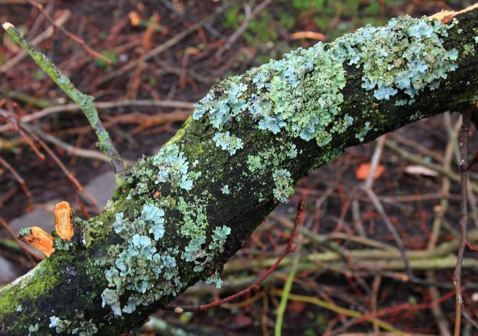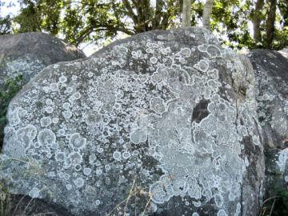Fungus provides nutrients to algae
  + Algae provides food to fungus

# Station 2

TICKS & FLEAS: relationship between parasites and animals

Tick on dog Flea on cat

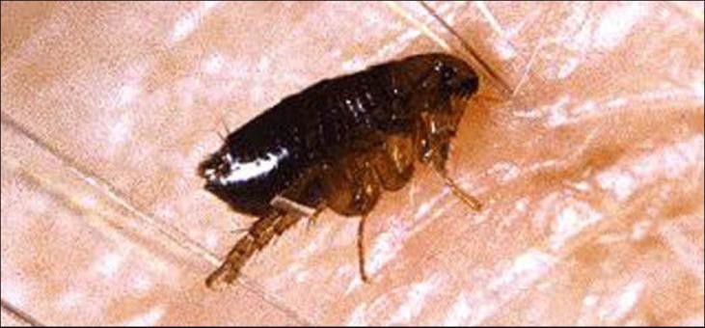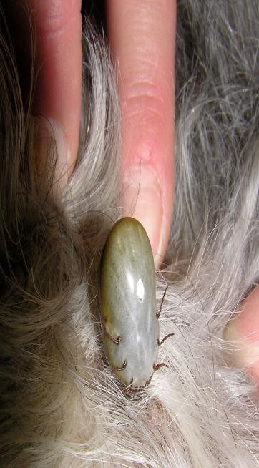 ▪ Parasites get nourishment from dog.

* Dog is harmed…. may become sick from bites/diseases transmitted by parasite.

# Station 3

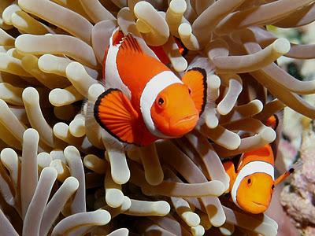CLOWN FISH & SEA ANEMONE: relationship between the clown fish and the sea anemone

* + Clown fish get protection from the anemone
  + Sea anemone get cleaned of parasites from the clown fish

# Station 4

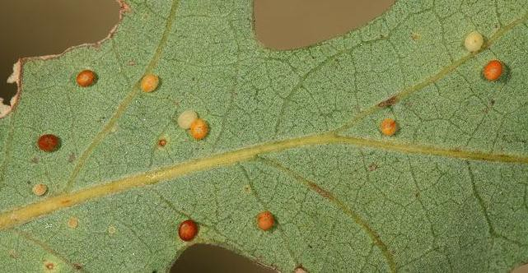GALLS ON OAK LEAVES: relationship between insects that make the galls and the oak tree.

* Insects form a nursery called a gall on the leaf/branch of a tree. Insects have a safe place to develop.
* Tree is not helped or harmed by the presence of the galls.

# Station 5

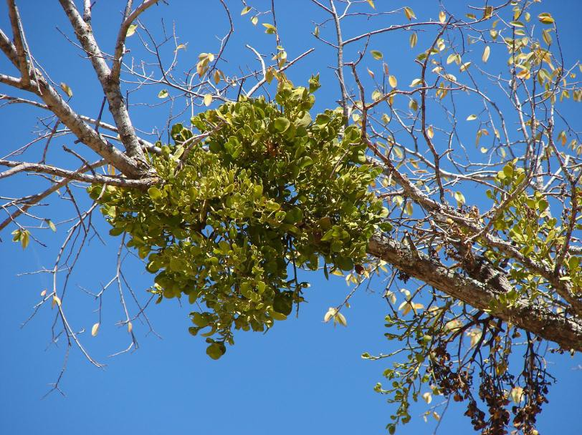MISTLETOE: relationship between mistletoe & the tree that it is attached to.

* + Mistletoe gets food and water from the tree.
  + Tree loses food and water that it needs…. eventually will die.

# Station 6

Shark & Remora Fish: relationship between the shark & remora fish

* + - 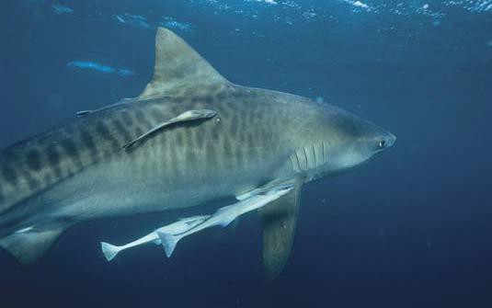Remora fish get free food by hanging out with sharks.
    - Sharks are not affected by presence of fish.

# Station 7

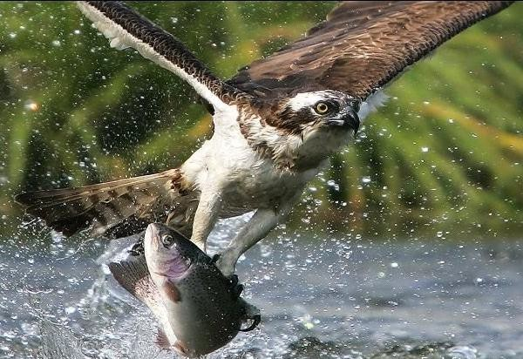Eagle & Fish: relationship between the eagle & fish

* + Birds of prey can spot fish swimming in a lake from high altitudes.
  + They swoop down, and grab fish to feed their young back in the nest.

# Station 8

Cow & Intestinal Bacteria: relationship between the cow & the bacteria in its intestine.

* + - 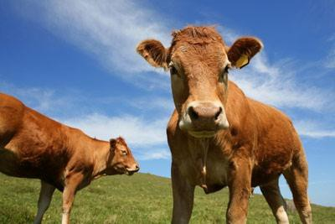Bacteria live in the intestines of cows and other organisms.
    - Bacteria help to digest food for the cow.
    - The cow provides a warm, moist environment to live.

# Station 9

Bighorn Sheep: relationship between 2 male bighorn sheep.

* 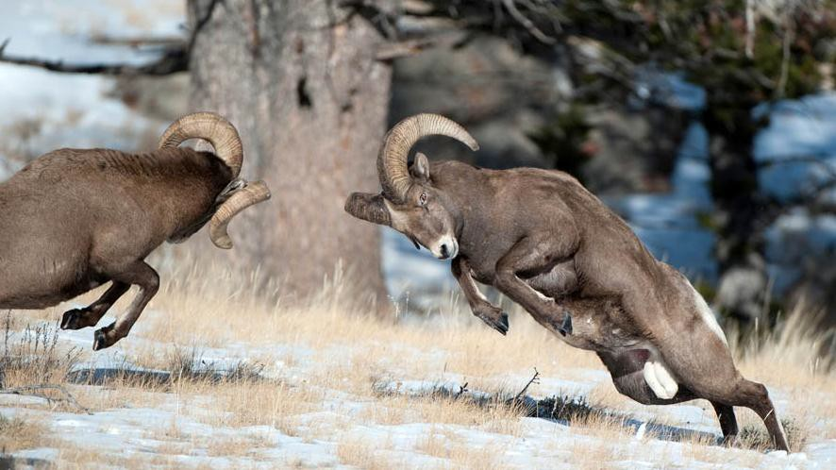Male bighorn sheep, called rams, butt heads to see which one is dominant.
* The dominant male can mate with more females than the non-dominant male sheep.

# Station 10

Athlete’s Foot: relationship between your toes and a fungus.

* Athlete’s foot is a fungus growing between and around human toes.
  + 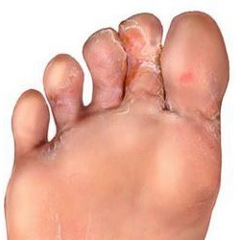The fungus gets nutrients from the human skin.
  + Athlete’s foot causes dry, scaly skin, itching, inflammation and even blisters.